**R project**

**Source code:**

>RawData <- read.table("Desktop/pima-indians diabetes.data",sep = ",",header=FALSE)

> RowData

> responseY <- RawData[,dim(RawData)[2]]

> predictorX <- RawData[,1:(dim(RawData)[2]-1)]

> pca <- princomp(predictorX, cor=T) # principal components analysis using correlation matrix

> pc.comp <- pca$scores

> pc.comp1 <- -1*pc.comp[,1] # principal component 1 scores (negated for convenience)

> pc.comp2 <- -1*pc.comp[,2] # principal component 2 scores (negated for convenience)

>

>

> X <- cbind(pc.comp1, pc.comp2)

> cl <- kmeans(X,13)

> cl$cluster

> plot(pc.comp1, pc.comp2,col=cl$cluster)

> points(cl$centers, pch=16)

**Screenshot:**

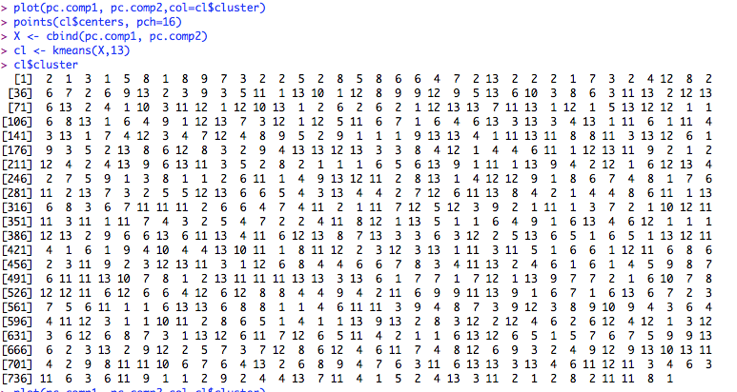Macintosh HD:Users:whng2:Desktop:Rplot.pdf

**Android Studio**

**Android voice recognition Screenshot:**